Eclipse Hibernate 基本環境設定及範例
- 安裝Hibernate 基本操作工具
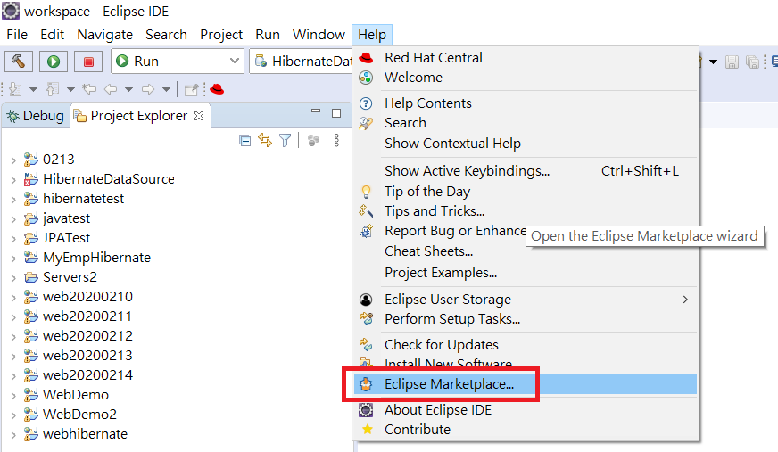
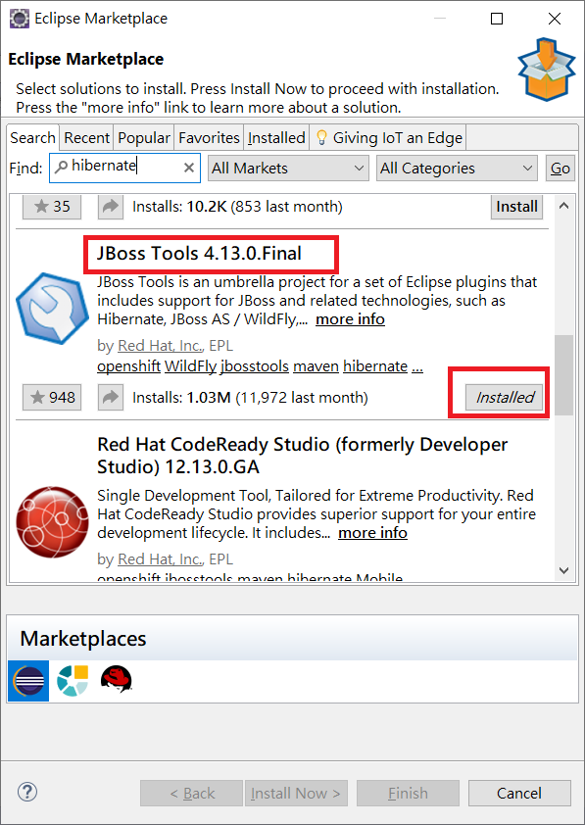

- 建立dynamic web project
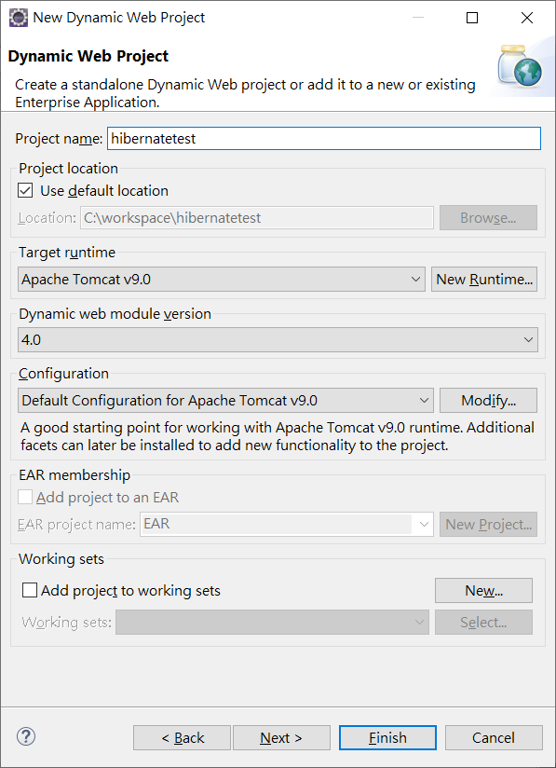
- 從資料庫建立Hibernate 相關 Entity class 及 Utility class
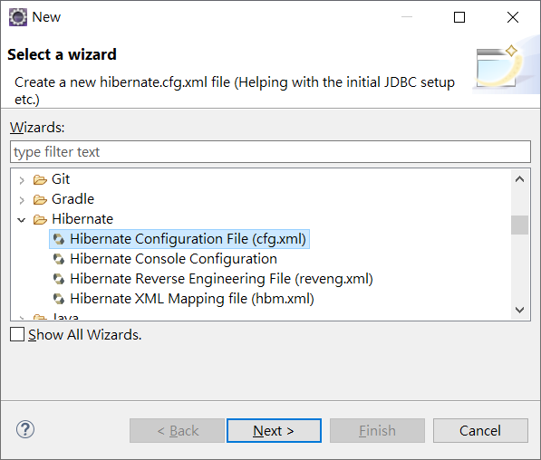
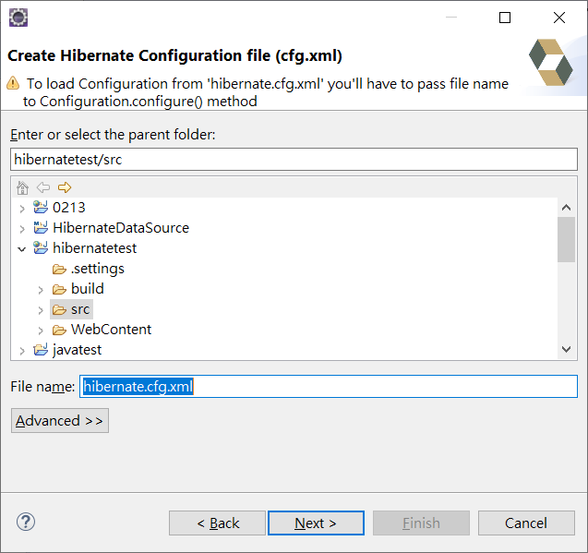

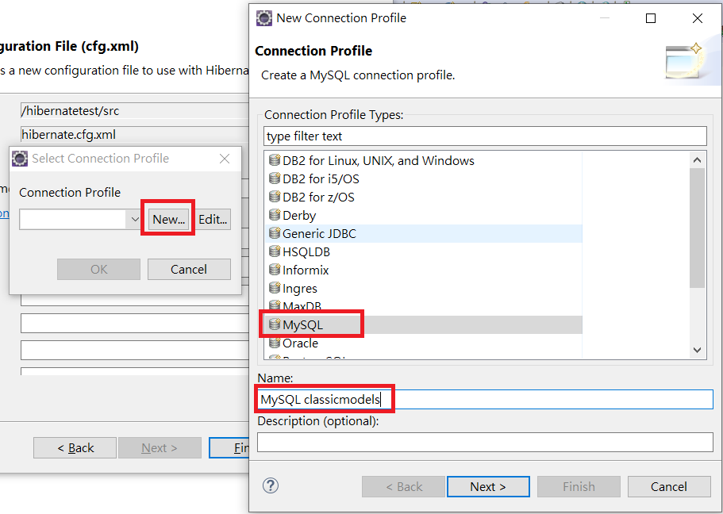
記得查看MySql Driver 版本是否正確
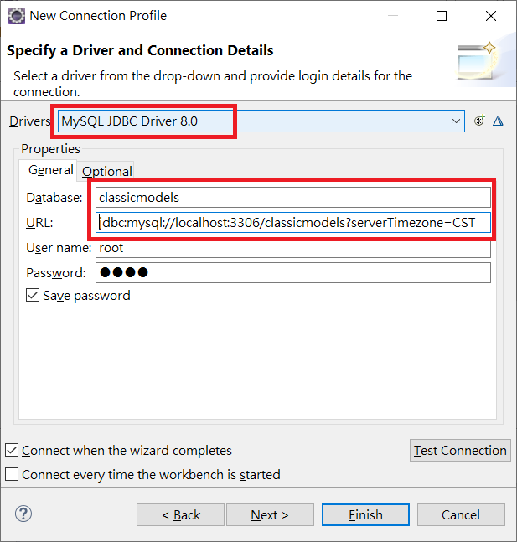
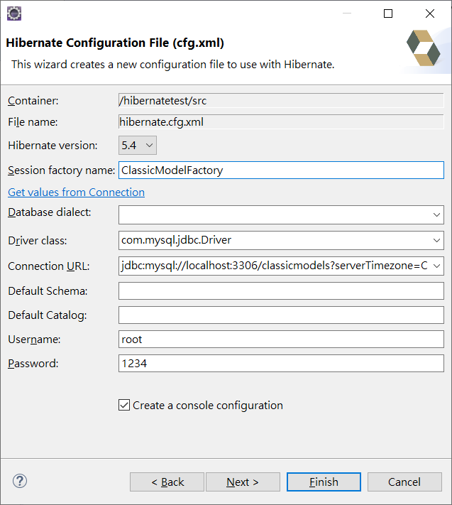
<?xml version="1.0" encoding="UTF-8"?>
<!DOCTYPE hibernate-configuration PUBLIC "-//Hibernate/Hibernate Configuration DTD 3.0//EN"
"http://www.hibernate.org/dtd/hibernate-configuration-3.0.dtd">
<hibernate-configuration>
<session-factory name="ClassicModelFactory">
<property name="hibernate.connection.driver_class">com.mysql.cj.jdbc.Driver</property>
<property name="hibernate.connection.password">1234</property>
<property name="hibernate.connection.url">jdbc:mysql://localhost:3306/classicmodels?serverTimezone=CST</property>
<property name="hibernate.connection.username">root</property>

<property name="hibernate.current_session_context_class">thread</property>
<property name="hibernate.query.factory_class">org.hibernate.hql.internal.classic.ClassicQueryTranslatorFactory</property>
<property name="hibernate.show_sql">true</property>
<mapping resource="model/Coffees.hbm.xml"/>
</session-factory>
</hibernate-configuration>

建立Entity Class
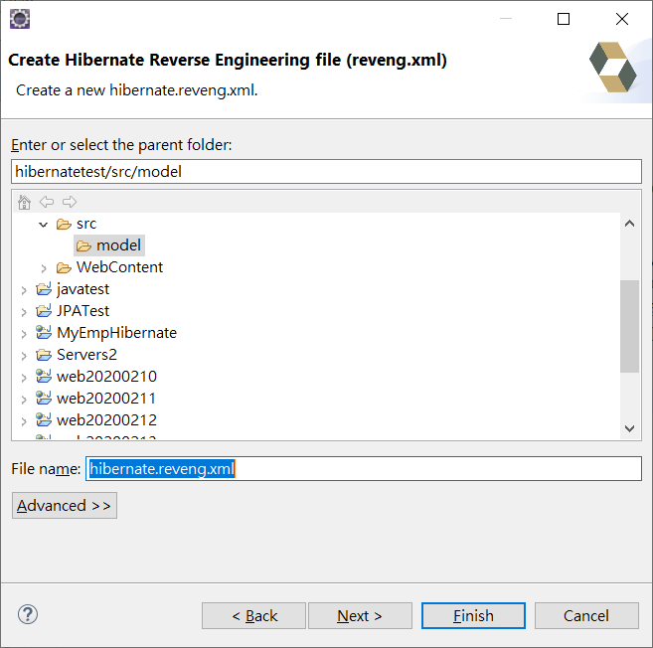

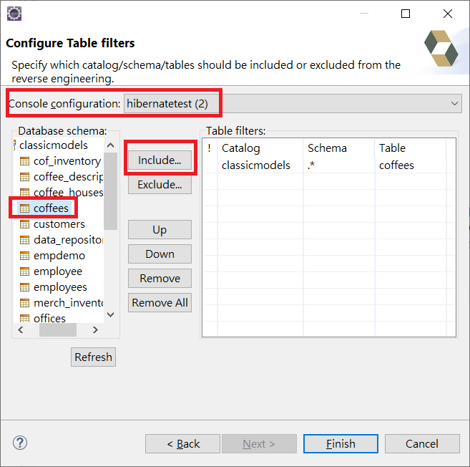
如果連線有問題重新製作一個 Hibernate Console Configuration

<?xml version="1.0" encoding="UTF-8"?>
<!DOCTYPE hibernate-reverse-engineering PUBLIC "-//Hibernate/Hibernate Reverse Engineering DTD 3.0//EN" "http://hibernate.org/dtd/hibernate-reverse-engineering-3.0.dtd" >

<hibernate-reverse-engineering>
<table-filter match-catalog="classicmodels" match-name="coffees"/>
</hibernate-reverse-engineering>

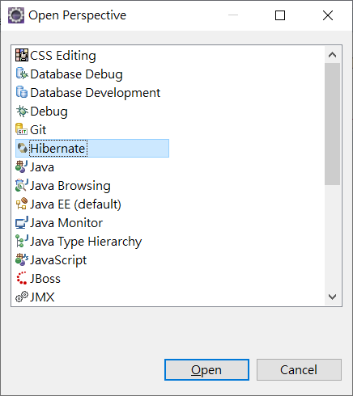
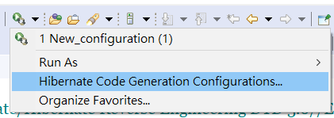
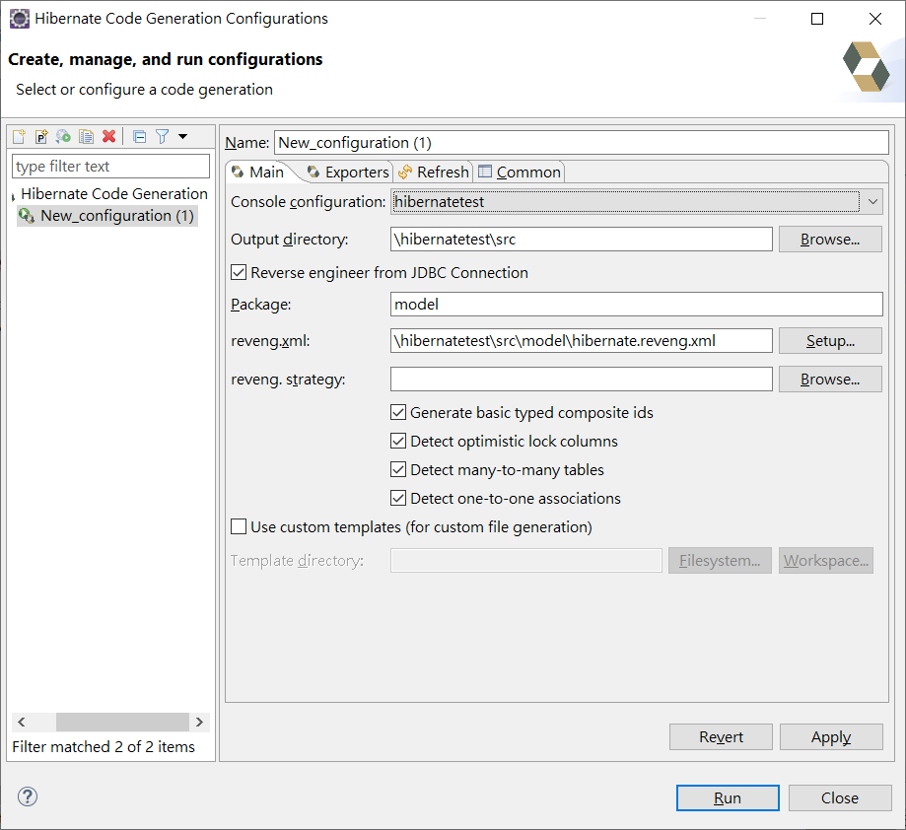
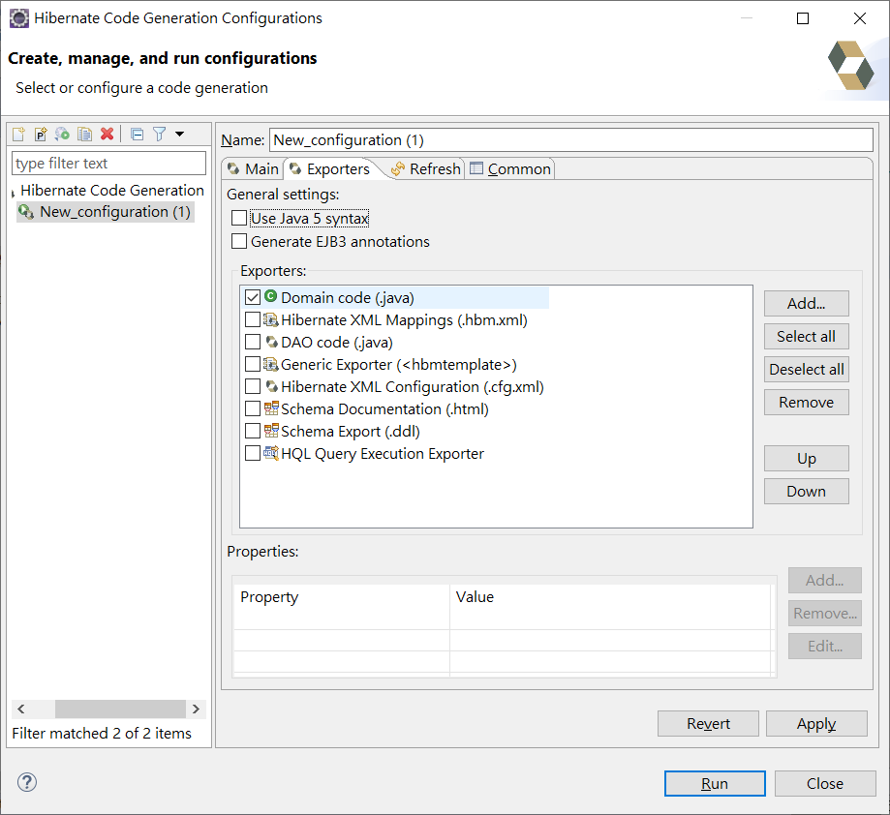

下載Hibernate Library
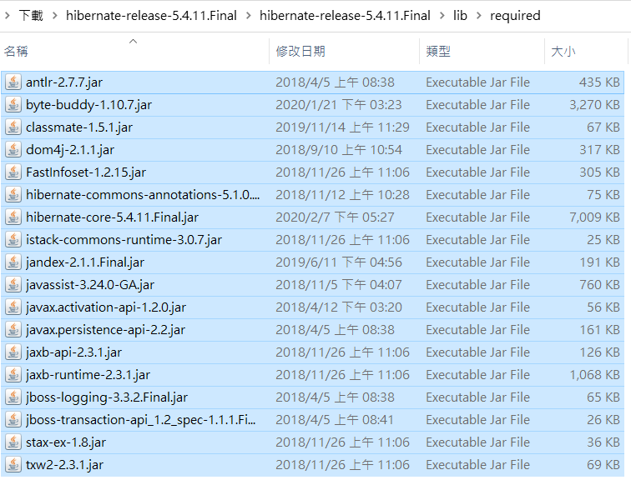
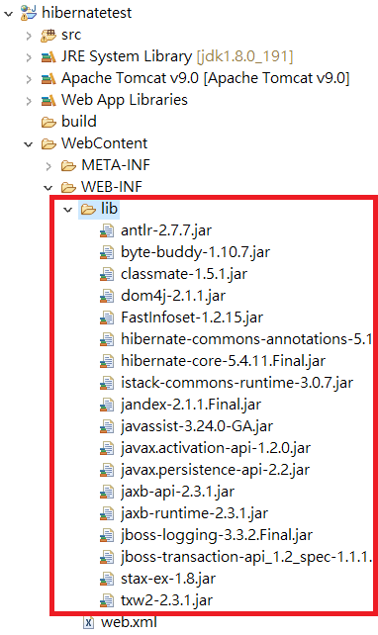
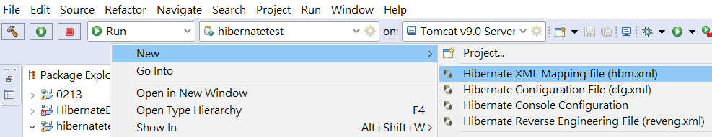
Entity Class 及 Table 欄位對映時
如果Table 欄位有底線會有錯誤
<?xml version="1.0"?>
<!DOCTYPE hibernate-mapping PUBLIC "-//Hibernate/Hibernate Mapping DTD 3.0//EN"
"http://hibernate.sourceforge.net/hibernate-mapping-3.0.dtd">
<!-- Generated 2020/2/18 ?W?? 10:35:48 by Hibernate Tools 3.5.0.Final -->
<hibernate-mapping>
<class name="model.Coffees" table="COFFEES">
<id name="supId" type="int">
<column name="SUP_ID" />
<generator class="assigned" />
</id>
<property name="cofName" type="java.lang.String">
<column name="COF_NAME" />
</property>
<property name="price" type="java.math.BigDecimal">
<column name="PRICE" />
</property>
<property name="sales" type="int">
<column name="SALES" />
</property>
<property name="total" type="int">
<column name="TOTAL" />
</property>
</class>
</hibernate-mapping>

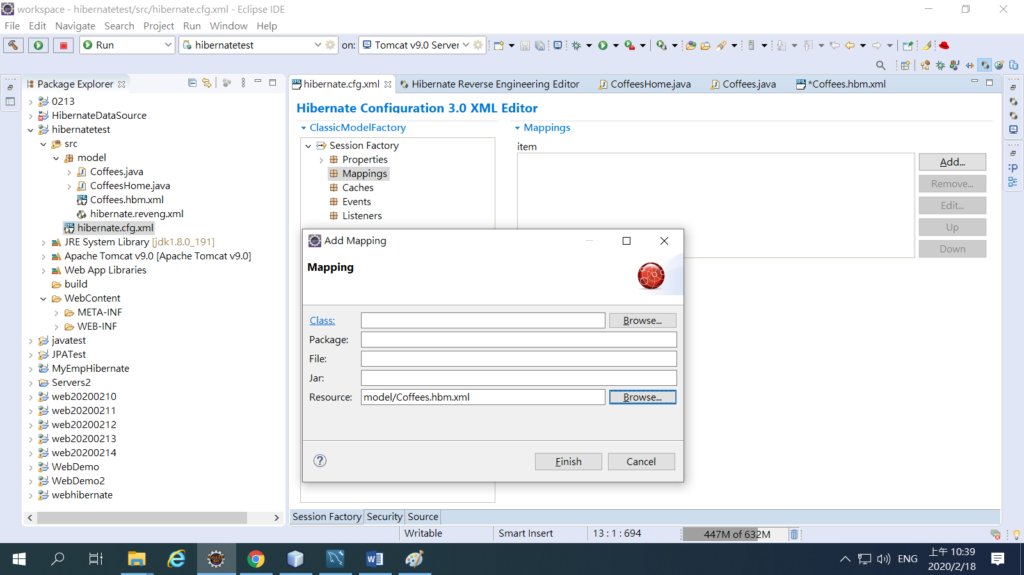
最後要做Hibernate Configuration Mappings -> Resource -> model.Coffees.hbm.xml

查詢Coffees
/*
* To change this license header, choose License Headers in Project Properties.
* To change this template file, choose Tools | Templates
* and open the template in the editor.
*/

import java.io.IOException;
import java.io.PrintWriter;
import java.util.List;
import javax.servlet.ServletException;
import javax.servlet.annotation.WebServlet;
import javax.servlet.http.HttpServlet;
import javax.servlet.http.HttpServletRequest;
import javax.servlet.http.HttpServletResponse;

import org.hibernate.Query;
import org.hibernate.Session;

import org.hibernate.SessionFactory;
import org.hibernate.boot.registry.StandardServiceRegistryBuilder;
import org.hibernate.cfg.Configuration;
import org.hibernate.service.ServiceRegistry;
import java.util.Properties;

/**
*
* @author Administrator
*/
@WebServlet(urlPatterns = {"/QueryServlet"})
public class QueryServlet extends HttpServlet {
private SessionFactory factory;
/**
* Processes requests for both HTTP <code>GET</code> and <code>POST</code>
* methods.
*
* @param request servlet request
* @param response servlet response
* @throws ServletException if a servlet-specific error occurs
* @throws IOException if an I/O error occurs
*/
protected void processRequest(HttpServletRequest request, HttpServletResponse response)
throws ServletException, IOException {

try {
factory = new Configuration().configure().buildSessionFactory();
} catch (Throwable ex) {
System.err.println("Failed to create sessionFactory object." + ex);
throw new ExceptionInInitializerError(ex);
}

Session session = factory.openSession();

// Query query = session.createQuery("from Coffees where price > :id ");
List list = session.createQuery("FROM Coffees").list();
//query.setParameter("id", 0);

// You can replace the above to commands with this one
// Query query = session.createQuery("from Student where studentId = 1 ");
// List<model.Coffees> list = query.list();

model.Coffees cf = (model.Coffees)list.get(0);

System.out.println(list);
response.setContentType("text/html;charset=UTF-8");
try (PrintWriter out = response.getWriter()) {
/* TODO output your page here. You may use following sample code. */
out.println("<!DOCTYPE html>");
out.println("<html>");
out.println("<head>");
out.println("<title>Servlet QueryServlet</title>");
out.println("</head>");
out.println("<body>");
out.println("<h1>Servlet QueryServlet at " +list.toString() + "</h1>");
out.println("</body>");
out.println("</html>");
}
}

// <editor-fold defaultstate="collapsed" desc="HttpServlet methods. Click on the + sign on the left to edit the code.">
/**
* Handles the HTTP <code>GET</code> method.
*
* @param request servlet request
* @param response servlet response
* @throws ServletException if a servlet-specific error occurs
* @throws IOException if an I/O error occurs
*/
@Override
protected void doGet(HttpServletRequest request, HttpServletResponse response)
throws ServletException, IOException {
processRequest(request, response);
}

/**
* Handles the HTTP <code>POST</code> method.
*
* @param request servlet request
* @param response servlet response
* @throws ServletException if a servlet-specific error occurs
* @throws IOException if an I/O error occurs
*/
@Override
protected void doPost(HttpServletRequest request, HttpServletResponse response)
throws ServletException, IOException {
processRequest(request, response);
}

/**
* Returns a short description of the servlet.
*
* @return a String containing servlet description
*/
@Override
public String getServletInfo() {
return "Short description";
}// </editor-fold>

}

